Department of Rural and Community Development

Local Enhancement Programme 2024

NOTE: Closing Date 4:00pm Friday 8th March 2024

INCOMPLETE APPLICATIONS WILL BE RETURNED
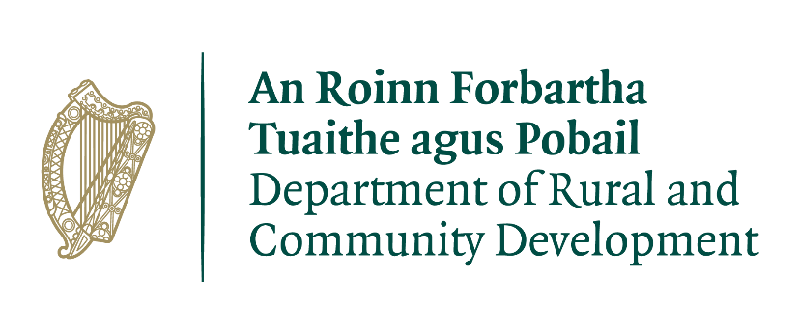
FOR OFFICE USE ONLY

Reference Number:

Date Received:

Date Stamp

LCDC recommendation:

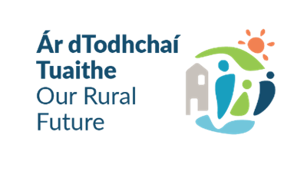
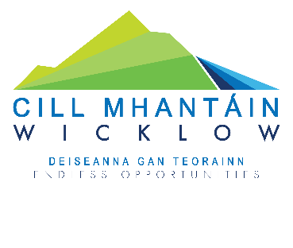

GROUP /ORGANISATION NAME

COMPLETED APPLICATIONS ARE TO BE RETURNED TO:

Wicklow LCDC,
Community, Cultural & Social Development,
Wicklow County Council,
County Buildings, Whitegates, Wicklow Town, Co. Wicklow. A67 FW96

OR SCANNED APPLICATIONS TO BE EMAILED TO:
lep@wicklowcoco.ie

By 4.00 p.m. on Friday 8th March 2024
CLOSING DATE WILL BE STRICTLY ADHERED TO.

ONLY FULLY COMPLETED APPLICATIONS WILL BE ACCEPTED. INCOMPLETE APPLICATIONS WILL BE RETURNED TO APPLICANT.

Please read the Application Guidelines for the ‘Local Enhancement Programme 2024’ before completing this form.

Department of Rural and Community Development
Local Enhancement Programme 2024

The Department of Rural and Community Development (“the Department”) funds the Local Enhancement Programme (LEP) which provides funding to support community groups across Ireland.

The Local Enhancement Programme 2024 will support groups, particularly in disadvantaged areas, with funding to carry out necessary repairs and improvements to their facilities, and to purchase equipment for example tables and chairs, tools and signage, laptops and printers, lawnmowers, canopies and training equipment etc.

Facilities improvement works may also include, but are not limited to; improved access for persons with a disability; enhancing community participation for disadvantaged and marginalised groups, and; improving energy efficiency of community facilities to reduce ongoing costs.

The scheme is designed to ensure local priorities are identified and met, so as to improve and enhance community facilities for all. It is administered by Local Community Development Committees (LCDCs) in each Local Authority area.

Applications should relate to one or more key priority areas identified in their LCDC’s Local Economic and Community Plan (LECP) in order to be eligible for consideration.

TERMS AND CONDITIONS

- The Local Enhancement Programme will support groups, particularly in disadvantaged areas, to carry out necessary repairs and improvements to their facilities and purchase equipment.
- This is a capital funding scheme. The scheme does not provide funding for the pay or employment of staff, or towards current ‘operating’ costs such as utility bills, etc.
- The activity or project must benefit the local community and relate to the key priority areas identified in the LECP.
- The information supplied by the applicant group /organisation must be accurate and complete.
- Inaccurate or incomplete information may lead to disqualification and/or the repayment of any grant made.
- All information provided in respect of the application for a grant will be held electronically. The Department reserves the right to publish a list of all grants awarded on its website.
- The Freedom of Information Act applies to all records held by the Department and Local Authorities, including applications received and any additional correspondence related to the application.
- The application must be signed by the Chairperson, Secretary or Treasurer of the organisation making the submission.
- It is the responsibility of each organisation to ensure that it has proper procedures and policies in place, including appropriate insurance, where relevant.
- Evidence of expenditure, receipts /invoices must be retained and provided to the LCDC, the Department of Rural and Community Development, the relevant local authority or any agent acting on their behalf if requested.
- Grant monies must be expended and drawn down from the LCDC by 31st December 2024. Photographic evidence may be required to facilitate draw down of grants.
- The Department of Rural and Community Development’s contribution must be publicly acknowledged in all materials associated with the purpose of the grant, including signage.
- Generally, no third party or intermediary applications will be considered.
- Late applications will not be considered.
- Applications by post should use the correct value of postage stamps and allow sufficient time to ensure delivery not later than the closing date of Friday 8th March 2024. Claims that any application form has been lost or delayed in the post will not be considered unless applicants have a Post Office Certificate of Posting in support of such claims.
- Breaches of the terms and conditions of the grants scheme may result in sanctions including disbarment from future grant applications.
- Please ensure the application form is completed in full. Incomplete applications will not be considered for funding.
- In order to process your application it may be necessary for Wicklow County Council to collect personal data from you. Such information will be processed in line with the Local Authority’s privacy statement which is available to view on https://www.wicklow.ie/LivingYour-Council/Governance/Privacy-Policy

All questions on this form must be answered. Please write your answers clearly in block letters.

SECTION 1 – YOUR ORGANISATION

Name of Group / Organisation

Address

Eircode

Municipal District (Circle as Appropriate) | Arklow | Baltinglass | Bray | Greystones | Wicklow | Countywide

Contact name

Role in Group/Organisation

Telephone number

E-mail

Website

Alternative Contact name

Alternative Telephone number

Alternative E-mail

Please provide a brief organisational description of your group / organisation e.g. committee structure, meeting schedule, existence of memo and arts documents, registration with Company Registration Office, the Charities Regulator etc.

Has your Organisation / Group registered with the relevant local Public Participation Network (PPN)?
YES ☐ NO ☐

If NO, please consider registering with the relevant PPN.

Year group/organisation established
What is the purpose of group / organisation

Successful applications for funding under this programme will only be paid to the applicant organisation’s Bank Account. Please ensure you have your Bank Account details to hand if your application is successful.

Have you received funding under any capital grants schemes from 2018 to current date- i.e. grants from Government Departments, Local Authority or LEADER for e.g.?

YES ☐ NO ☐

If YES, please give details below:

Name of scheme | Funding organisation | Works / Purchases Funded | Amount received | Date received

If any of the above funding was paid through the Local Authority, have you submitted your Bank Account Details previously?

YES ☐ NO ☐
Do you receive funding from any other organisation?

YES ☐ NO ☐

If YES, please give details below:

Funding organisation | Purpose of Funding | Amount received | Date received

Is your organisation affiliated or connected to any relevant local regional or national body?

YES ☐ NO ☐

If YES, please give details below:

Name of organisation(s):

How does your organisation link in with other organisations in your area?

Charitable Status Number (if applicable)

Tax Reference Number (if applicable)

Tax Clearance Access Number (if applicable)

SECTION 2 – Project Details

How much funding are you applying for? Tick one of the below options.

☐ Small scale grant of €1,000 or less

☐ Grant in excess of €1,000

PURPOSE OF GRANT

What will the funding be used for? (input answer below)
Note: This list is not exhaustive, but gives examples of types of expenditure that may be eligible

☐ IT Equipment ☐ CCTV ☐ Training Equipment
☐ Safety Equipment ☐ General Equipment ☐ Sports Equipment
☐ Machinery ☐ Construction Works ☐ Energy efficient upgrade
☐ Renovation of building/premises ☐ Development of community facilities
☐ Maintenance of building/premises ☐ Improved access for persons with a disability
☐ Other (Give details)

What is the purpose of the grant? (Outline details of the project).

Please input exact location (X-Y co-ordinates) of where the proposed project will based.

Y ITM
X ITM

This information is required in ITM format. The simple guide we have provided with this form will show you how to find these on https://irish.gridreferencefinder.com/

IF X-Y CO-ORDINATES (NOT EIRCODE) ARE NOT ENTERED ABOVE, THE APPLICATION FORM WILL BE DEEMED TO BE INCOMPLETE AND WILL NOT BE CONSIDERED.

If this is for a specific project, when will your project begin?

If this is for a specific project, when will your project be completed?

Are all relevant permissions in place (e.g. planning permission, written consent from landowner/property owner if your project involves the development of a property)?

Not applicable ☐ YES ☐ NO ☐

Is this part of a phased development and/or linked with (or funded by) other schemes operated by Government Departments or the Local Authority?

YES ☐ NO ☐

If YES to previous question please provide the details below:

FUNDING

Please provide details for all sections i.e., A, B, C and D below.

- Amount being applied for under the LEP for
€ (A)
equipment or the upgrade of facilities
☐Partial | ☐Total

- Is this amount a partial or total project cost?
€ (C)

- If partial, give the estimated total project cost

- Please include supporting documentation outlined below for your project. The Local Authority may also request specific documentation to support the application e.g. Bank statement to confirm available funds.

Important note: Please include supporting documentation. If your total project cost is less than €5,000 and is not related to building/landscaping/construction works e.g. equipment, then please include estimates/quotes from a minimum of three different independent suppliers with this form. For all other cases, please contact the lep@wicklowcoco.ie for information on the required supporting documentation.

To be eligible for funding under this programme you must state where you will source any shortfall of funding. Please provide these details below.

Source | Amount

Please state how your group proposes to publicly acknowledge the Department of Rural and Community Development

The LCDC will check to ensure that this application works towards addressing priorities within its Local Economic and Community Plan (LECP) which you can access on your local authorities’ website. If your application is for an amount greater than €1,000, please complete the below table to state which key priority area(s) in the LECP this grant application relates to and the estimated number of people to benefit.

If your application is for a small scale capital grant of €1,000 or less, then you may wish to complete the below table, but you are not required to do so.

Key priority area of LECP | No. of beneficiaries

SECTION 3 - DECLARATION

PLEASE NOTE BEFORE SUBMITTING:

ONLY FULLY COMPLETED APPLICATIONS WILL BE ACCEPTED.

INCOMPLETE APPLICATIONS WILL NOT BE CONSIDERED.

- I declare that the information given on this form is accurate and correct to the best of my knowledge.

- I confirm I have read and fully understand the Terms and Conditions of the ‘Local Enhancement Programme 2024’ (see page 2 of this form).

- I confirm that I have read the Application Guidelines for the ‘Local Enhancement Programme 2024’ prior to completing this form.

- I confirm that this grant application is submitted in acceptance of and compliance with the Terms and Conditions.

- I confirm that the applicant group/organisation does not have the funding to undertake the work/project without this grant aid or alternatively that the grant will facilitate a larger project which they would otherwise be unable to afford.

- I confirm that the applicant group/organisation is tax compliant (if tax registered).

Name in block capitals (on behalf of group / organisation):

Signature:
(Please note a typed signature will not suffice)

Position held in group / organisation (block capitals):
Date:

